PIEZOELECTRIC ENERGY HARVESTING AND INTEGRATION WITH OTHER ENERGY RESOURCES FORMED AS A MICROGRID

IEEE RVRJCCE Student Branch, Guntur, SB Code: SBC55201

Jeevan Prasad Gnanavelu  
IEEE Mem.No: 100037389  
 R.V.R. & J.C. College of Engineering. Guntur, Andhra Pradesh, India. jeevanreguvel[@gmail.com](mailto:kiranreddymasarla@gmail.com)

Varshitha Joy Devarakonda  
IEEE Mem.No: 100040910  
R.V.R. & J.C. College of Engineering. Guntur, Andhra Pradesh, India.  
varshithadevarakonda8@gmail.com

Purushotham Bhupathi  
IEEE Mem.No: 100040824   
 R.V.R. & J.C. College of Engineering. Guntur, Andhra Pradesh, India. bpurushotham016@gmail.com

Chakradev Santosh Pavankumar Manda  
IEEE Mem.No: 100040844   
 R.V.R. & J.C. College of Engineering. Guntur, Andhra Pradesh, India. chakradevmandaspk@gmail.com

D.V.S.R.K.Murthi  
IEEE Mem.No: 99000620   
 R.V.R. & J.C. College of Engineering. Guntur, Andhra Pradesh, India. dvsai2004@gmail.com

K. Abhinav Sesha Srinivas  
IEEE Mem.No: 100037374   
 R.V.R. & J.C. College of Engineering. Guntur, Andhra Pradesh, India. seshasrinivasa@gmail.com

***Abstract- Now-a-days, harvested energy from the surrounding environment plays an important role in human life. This type of energy gradually replaced for traditional energy such as fossil energy. Serval methods have been used to capture green energy from environment sources. Focusing in the recent years reaches are focused on trying to harvest energy from every possible source which are available freely. Harvesting energy from sources which don’t result in significant contribution towards the energy needs is called energy scavenging, which promotes saving energy ounce of energy. One such example is to tap electrical energy by making use of the force exert by humans as they walk. This pressurized weight energy can be converted to the electrical form using piezoelectric crystal. Electrical energy can also be tap from sound waves or sound vibration through the piezoelectric material. The energy from the air spring used in traction also collected by using the piezoelectric material. One of the most popular possible energy resources is solar energy which is converted by the help of the PV panel. There are many possible energy resources in the environment which can be harvested. The energy harvesting is used to meet the demand in order to get real time pricing. In this paper, various energy harvesting methods will be studied with the possible combinations of capturing of energy, storage and conversion. The convertor topologies used for the conversion of energy is presented in this paper. The harvested energy may be used for the load or fed to the grid or otherwise it will form as a Micro grid.***

Keywords— *Piezoelectric energy through pressure, sound, and Air spring of trains – solar power- Electromagnetic Energy-Electrostatic energy- Uncontrolled Rectifier-Piezoelectric crystal – Electric Vehicle battery – Battery- Regulators- Inverters- Filters- Bi-directional power Converters.*

I. INTRODUCTION

Nowadays energy is one of the most important issues around the world. As we know natural resources will finish one day. That’s why researchers are trying to introduce substitute energy sources from nature. That must be green and not harmful to the environment. Energy harvesting is defined as “Capturing minute amounts of energy from one or more of

the surrounding energy sources. Human beings have already started to use energy harvesting technology in the form of the windmill, geothermal and solar energy. The energy came from natural resources, termed renewable energy. Renewable energy harvesting plants generate kW or MW level power, which is called macro energy, and also can produce from natural resources, that called micro energy harvesting. Micro energy harvesting technology is based on mechanical vibration, mechanical stress and strain, thermal energy from furnaces, heaters, friction sources, sunlight or room light, the human body, and chemical or biological sources, which can generate mW or microwatts level power. Micropower supply needs are increasing greatly with time as our technology is moving to the micro and nanofabrication levels.

Energy harvesting becomes more and more important in our life. Energy is harvested from the ambient environment such as mechanical, thermal, light, electromagnetic, human body, etc to replace traditional sources. Mechanical energy harvesting is the most promising of several energy harvesting techniques: it uses piezoelectric components that transfer the vibration energy to the electric energy. This electrical energy can be regulated and stored before use by electronic devices where the replacement of the batteries is impractical, Such as wireless microsensor networks, implementable medical electronics, and tire pressure sensor systems. The need for energy is ever-increasing. The International Energy Outlook 2017 estimated that the total energy consumption in the world would increase from 575 quadrillion British thermal units (Btu) in 2015 to 736 quadrillion Btu by 2040, which would be a spike of 28%. India and China alone are estimated to account for more than fifty percent of the net increase in the world’s energy consumption over the projected period from 2015 to 2040.

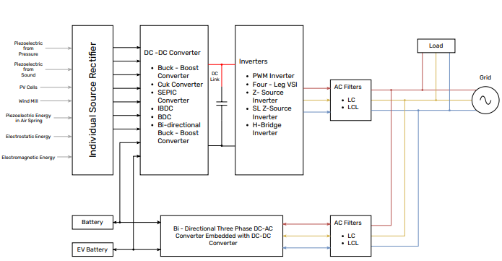

Fig.1: Block Diagram of Energy Harvesting and Integration with Other Resources.

A transducer is a sensor transferring vibration energy into electric energy [1-3]. The transducer is usually modeled by a current source in parallel with a capacitor and a resistor. The electrical energy at the output of the transducer is a strong and irregular function of time; hence, the AC-DC is needed to produce a DC supply source. The energy after the rectifier is stored in energy storage such as a battery or supercapacitor. Before using in load, normally a voltage regulator is needed to regulate suitable voltage. With its prevalence in urban environments, Sound energy becomes very attractive as a possible energy resource to harvest. Efficient ways of harvesting environmental noise into electrical energy are a big challenge since acoustic energy comes from its low power density. Therefore, sound wave energy harvesting gas created excessive attention among researchers, scientists, and engineers. The main profits of the sound wave energy harvesting system are that it involves minimum maintenance which is suitable to be arranged in large-scale or previously inaccessible locations. Sound energy is available in some circumstances such as airports, construction sites, factories, etc. It is a hygienic and supportable energy source. Investigating sound energy becomes a great concern to transform ambient energy into practical and usable electrical energy.

In this paper, the basic converter used is a Full Bridge uncontrolled rectifier for the conversion of the AC to DC conversion. Later it is fed to the Regulator for the constant DC Supply. The constant DC supply is fed to the three-phase inverter or the Battery. Later on, the inverter output is fed to the Grid (or) three-phase Load through the Filters. The different types of converters are presented in this paper, which may use while converting power. The Block diagram of the integration of the energy harvesting into the Grid forms a Micro-Grid as shown in Fig.1

**II. ENERGY RESOURCES**

***1. Solar Photovoltaic cell:***

A photovoltaic cell converts solar energy directly into electricity by the photovoltaic effect [4]. It is manufactured from semiconductor material and has a p-n junction with a specific energy band gap. When sunlight of a suitable wavelength falls on their surface, the energy from photons is transferred to the electrons in the semiconductor material, and they jump to the conduction band from the valence band when input energy is higher than threshold energy, thus attaining an excited state. These electrons become free to move, this facilitates the motion of electrons and holes, thus causing the flow of electricity.

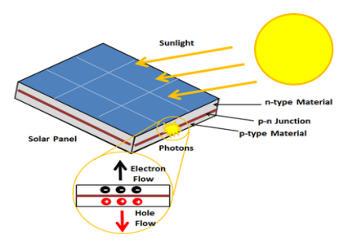

Fig.2: Photovoltaic Effect in PV Cell.

Its efficiency depends on factors like the wavelength of incident solar energy, operating temperature, solar irradiance i.e. solar power obtained from the sun per unit area, etc. The efficiency can further be improved by using multi-junction PV cells comprising different band gaps, using monocrystalline cells or more efficient semiconductor material such as Gallium Arsenide (GaAs), or by using concentrated photovoltaics. Fig.2 shows the Photovoltaic Effect in PV cells.

***2. Piezoelectric Energy:***

***Vibration Source:***Piezoelectric energy harvesters have been extensively used for their large densities. Piezoelectric material is widely used in vibration applications. The vibration factor alters the piezoelectric material by applying a force on it, giving it the bending shape that creates an electric charge. Many piezoelectric materials have been used, but the most popular material used in transduction processes today is Lead Zirconate Titanate (PZT) along with the polymer material polyvinylidene fluoride (PVDF). PZT is favored due to its abundant vibration accessibility and high piezoelectric constants. The first piezoelectric energy harvesting mechanism was implemented in human-wearable electronic applications.

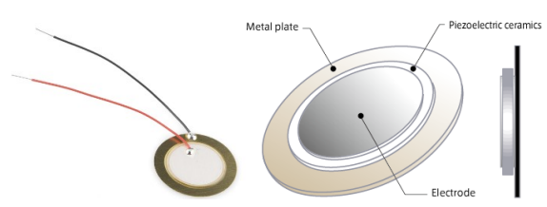

Fig.3: Piezoelectric Transducer and its part.

It was first fabricated in a Media lab at t Massachusetts Institution of Technology in the late 1990s [5]. The idea was implemented in shoes, every step of a king will put a bending force on the piezoelectric materials installed in the shoe which will produce power produce power [6]. Optimizing the mechanical to electrical conversion can be achieved by folding piezoelectric material to form multiple layers in parallel shapes to form piezoelectric stacks. These layers can be connected electrically in series to increase the voltage produced [7]. Fig.3 Shows the Piezoelectric Transducer and its parts.

***Sound Vibration Source:*** For sound wave energy harvesting, it is proposed to use a vibration mechanism. The sound produces mechanical energy which then converts to electrical energy using a transduction mechanism, such as electromagnetic (inductance), electrostatic (capacitive), or piezoelectric. Most harvester’s practically usable forms can provide low output power than those stored in some applications. Due to its prevalence in an urban environment, sound energy becomes very attractive as a possible energy resource to harvest. Efficient ways of harvesting environmental noise into electrical energy are a big challenge since acoustic energy comes from its low power density. Therefore, sound wave energy harvesting has created excessive attention among archers, scientists, and engineers. The main profits of the sound wave energy harvesting system are that it involves minimum maintenance which is suitable to be arranged in large scale or previously inaccessible locations. Sound energy is available in some circumstances such as airports, construction sites, factories, etc. It is a hygienic and supportable energy source. Investigating sound energy becomes a great concern to information the ambient energy into practical and usable electric energy. [8]

***Piezoelectric energy harvester embedded in an air Spring:*** The irregularities of the track generate some excitations at the wheel-axle set during the train ride. Although filtered by the primary suspension systems, vibrations are transmitted to the bogie frame and therefore to the air springs (Fig.4). To harvest this energy from vibrations, we propose to introduce a device inside the closed volume of the air spring that is integral with the lower plate.

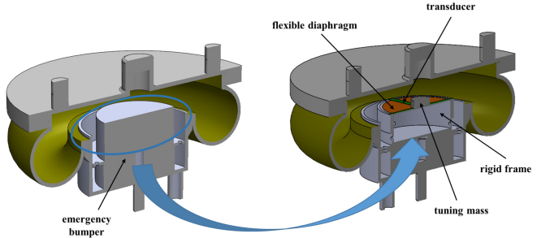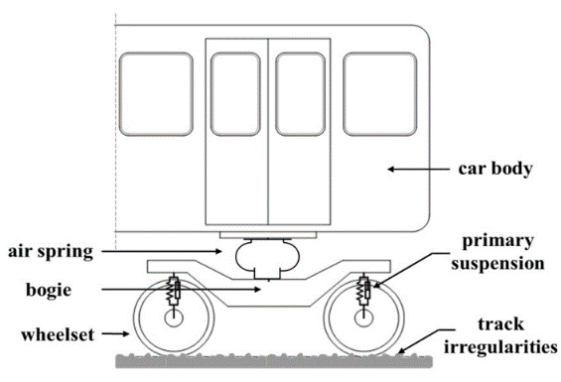

Fig.4: Scheme of train layout.

Considering that track irregularity is a random process with statistical regularity, which generates a broadband excitation, rail vehicle vertical dynamic response depends more on its characteristics than on the specific irregularity profile. Thus, the prominent excitation frequency for a train depends on the type of vehicle and body/suspension design. However, a frequency range can be identified and in particular, for bogies, the exaction frequencies for rigid vertical modes (pitch and bounce) vary from 5 to 15 Hz. The knowledge of the prominent frequency of the vehicle’s vertical vibrations is a fundamental input for the harvester design. Indeed, the design of the generator must be conducted to tune its resonance frequency on this value to harvest an energy amount as large as possible. This work describes the study conducted to evaluate the energy generation of a device consisting of a resonant system and a piezoelectric transduction mechanism located inside the air spring, replacing and /or including the internal bumper. The latter can be set outside the below or can be redesigned to include the harvester.

For simplicity, here the first case was analyzed remarking that everything in the following can be extended to the second one. Placing the device in the seat of the emergency bumper must respect the geometrical constraints and shapes due to the available space.

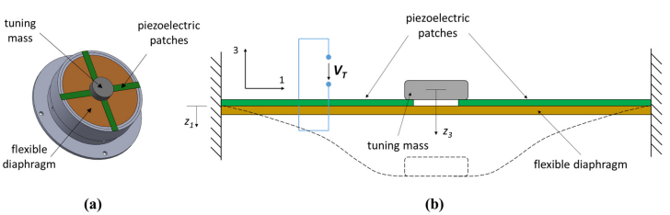

Fig.5: Piezoelectric energy harvester: a) axonometric projection and b) enlarge schematic section.

The layout of the energy harvester that meets the needs of integration with the air spring is shown in Fig. 6 via a sectional view. A flexible diaphragm (FD) connected by a cylindrical rigid frame at the air spring lower plate is the resonant system. The rigid frame presents a hole at the base and some holes on the side surface to avoid damping effects. A stunning mass is installed at the center of the FD to set the device’s natural frequency at a required value. Fig.5 shows the piezoelectric energy harvester from different views.

Fig.6: Design of Energy Harvesting system integrated with Air Spring.

In this study commercial Piezoelectric transducer was used to convert the mechanical energy into electrical. Some rectangular Piezoelectric films were arranged in a radial pattern on the upper surface of the flexible diaphragm and were made integral with it. The thin piezo-ceramic film is covered with an electrically conducting material to ensure electrical contact and is subsequently embedded in an elastic composite polymer. The material of the piezo-ceramic film is a modified Lead Zirconate-Lead Titanate. The operating principle of the device integrated into the air spring is described below. Being the Flexible Diaphragm support frame integral with an air spring lower plate, it receives wholly the vibration of this element, which is generated by track irregularities and transmitted by the bogie frame. These vibrations, making the Flexible Diaphragm resonant at the desired frequency by the use of opportune tunning mass, can be amplified to extract, convert, and harvest energy [9].

***3. Electromagnetic Energy Harvesters:*** The electronic magnetic harvesters were implemented initially in the first electric motor by Michael Faraday. The theory that stands behind this technology is the use of magnetic induction to generate electricity. From this, the conversion of mechanical energy to electric energy and vice versa became possible. A stretching-based nonlinear electromagnetic energy harvester was designed, modeled, and validated experimentally. This design used FR4 as spring material which is considered a low-frequency component due to its low Young’s Modulus (21 GPa). This design was built asymmetrically causing non-linearity. Non-linearity enhances producing large amplitude oscillations at low-frequency components. The main advantage of non-linear asymmetric states is that they can obtain more power at the resonating peaks than the linear symmetric states. It was shown that the power generated is equal to 0.14 µW Which is three times highethanam the system with a symmetric state. Another work was done by Podder et al in which they proposed a bi-stable electromagnetic vibration energy harvester using FR4 material. This design was proved to generate 22µW at 35 Hz frequency and 0.5 g acceleration. It was also shown that using linear components, the frequency is raised by 5 Hz compared to the nonlinear bi-stable device. Fig.7 shows the Energy harvesters for lateral Vibrations of Shafts. [10].

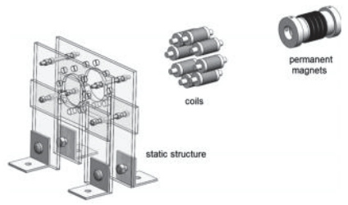

Fig.7: Energy Harvester for lateral vibration of shafts.

Another energy harvesting model was proposed using a combination of both piezoelectric and electromagnetic transducers. In this paper, a comparison of the power output between a hybrid two-degree-of-freedom (DOF) system with both transducers and more or two DOF systems with a stand-alone conversion mechanism was conducted theoretically and experimentally. It was noticed that the hybrid 2DOF was more advantageous than others. In summary, for applications that require low-power sources, electromagnetic generators have been used for this purpose. They work at low frequencies and require driving loads of very low impedance. Electromagnetic energy harvesters can produce power up to 140 mW in low-frequency environments. While in large-scale vibrations, the output power can reach 2 Watts or more. The main advantage of this type of transducer is the easiness of manufacturing which makes them reliable. Also, the size of electromagnetic energy harvesters can be at a macro-scale which makes them easy to implement. The main disadvantage of electromagnetic energy harvesters is the very low voltage output.

***4. Electrostatic Energy Harvesters:***  Electrostatic transducers are different from piezoelectric and electromagnetic transducers. The first is capacitive, while the others are inductive. Electrostatic conversion works through the movement of two plates relative to each other with a dielectric in between, forming a variable capacitor. The main disadvantage of this type of transducer is the need for two power sources to start the processes of energy harvesting. This is because the capacitor has to be charged with the initial voltage. Another disadvantage is the difficulty in manufacturing since the two plates cannot touch. Electrostatic devices are considered more appropriate for small-scale energy harvesters. The advantages of electrostatic energy harvesters are the following: high output voltage, easy adjustment of coupling coefficients, and low complexity. Whereas the disadvantages are: low capacitance and low energy densities. Electrostatic energy harvesters can output power up to 50µW [10].

***5. Electric Vehicle Battery:*** EV batteries have significant energy storage potential that can be used in demand-side management and as arbitrary storage. India has set up a goal to achieve 30% roadside electric vehicles by 2030 and is expected to save 5 crore liters of fuel every year to reduce 5.6 tonnes of annual carbon emissions. In India, EV technologies are growing with the use of unidirectional chargers of charging levels 1 and 2. Due to the limitation of the unidirectional charger, the potential of discharging the battery is not used at an extensive level. Currently, charging an EV is an uncontrolled process where the EV is plugged into the charger at a fixed power and chargers until the SoC is 100%. The specific feature of electricity feeding back on the power grid, V2G is the most promising opportunity to use EVs in the power system by converting established charging facilities to smart charging. V2G can provide a way to produce revenue for the consumers by supporting abundant scale RES and benefit both the system operators and vehicle owners. In certain energy markets, it is economically viable to supply electricity to their microgrids [11].

**III. CONVERTER TOPOLOGIES**

***1. Full Wave Bridge Rectifier:*** Full-bridge rectifier is commonly used as a rectifier circuit to convert the AC output of a piezoelectric to a DC voltage. The rectifying circuits consist of 4 diodes. The voltage needs to rectify due to the need for a constant supply of voltage to the Load. The Rectified output voltage is a pulsating DC, the DC Filter is used to get the Pure DC Output. The Output of the Full-Wave Bridge Rectifier is fed to the Regulator for the output constant DC Supply.

***2. Regulators:*** The regulator is used for the Constant DC supply with the variable input supply. The most popular regulators are Buck-Boost Converters. The Buck-Boost converters’ Topology is various types based on the application used. The Buck-Boost Converter may be an Isolated or Non-Isolated Converter. The Isolated converter is used for a better power factor, but in the case of this application, the energy harvested is very low. So, the isolated converter is not used because of the less Efficiency. The Non-isolated Converter is used for better Efficiency and Constant DC is fed to the PWM Inverter. The power factor improvement is done in the Inverter Section. The Topology of the Converters based on the application is as follows:

*Buck-Boost Converters:* The non-isolated topology of the buck-boost converter is shown in Fig.8. It provides buck or boosts voltage at the output side compared to the input side. This converter operates as a bidirectional in which output may be step-up or step-down voltage as per requirement. This type of bidirectional topology is used for regenerative energy recovery of railway applications. This circuit is formed by using one buck and one boost converter. They are connected in series with one another provided that their duty cycle must be the same. It is operated in 3 modes. In Mode 1, after the switch is ON, supply voltage Vs supplies current which flows through Vs – Switch - L- Vs. During this diode, D is OFF and the inductor is getting charged and stores energy. The voltage that appears across the inductor is source Voltage V. In Mode 2, the Switch is OFF; the Inductor releases its energy by passing current through C as well as load resistance. During this period D is ON and the Capacitor is charged. The voltage across R is inductor voltage. The inductor charged the capacitor with a lower plate positive and upper plate negative and In mode 3, diode D and Switch id OFF. Now capacitor voltage appears across at output which is negative so that is also called an inverting regulator. The efficiency of the converter is Low and the Cost is medium due to the floating drive. [12,13,16]

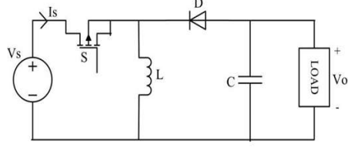

Fig.8: Buck-boost converter

*Cuk Converter:* The Cuk converter is a type of DC/DC converter that has an output voltage magnitude that is either greater than or less than the input voltage magnitude. It is essentially a boost converter followed by a buck converter with a capacitor to couple the energy. Similar to the buck-boost converter with inverting topology, the output voltage of non-isolated cuk is typically also inverting and can be lower or higher than the input. It uses a capacitor as its main energy-storage component, unlike most other types of converters which use an inductor. It is named after Slobodan Cuk California Institute of Technology, who first presented the design. There are variations on the basic cuk converter [13,14,16]. Fig.9 shows the circuit diagram of the cuk converter.

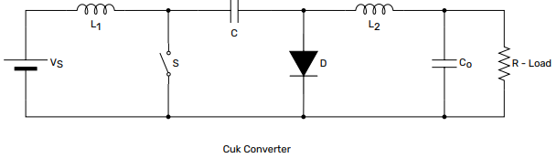

Fig.9: Cuk Converter

*SEPIC (Single-Ended Primary Inductor) Converter:* This converter allows its potential output to be stepped up or stepped down or similar to its input. Its output control by varying the duty cycle of S. If the duty cycle is above 0.5 it will step-up and when its duty cycle is below 0.5, it will step down. It is the same as a buck-boost converter. Except that it has the advantage of having output non-inverting. When switch S turns ON inductor L1 is charged by the input voltage and L2 is charged by the coupling capacitor. In this case, diode D is OFF and the output is maintained by C2. When the switch is OFF, both the output of inductor L1 and Inductor L2 charge the capacitor C2 through diode D. Its supply output of lower ripple and provides lower potential stress in capacitor C1 which is superior to the CUK converter. Isolation in input and output is easily provided. This type of converter is mainly used for the application of higher voltage. The characteristics of this converter are it is a buck and boost voltage easily, non-inverting output, series capacitor, and pulsating output current [13,16]. The topology of the Sepic is shown in Fig.10.

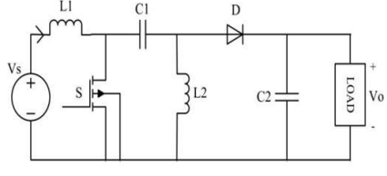

Fig.10: SEPIC converter.

*Bridge Type Dual Input DC-DC (BDC) Converter:* The converters mentioned in much of the literature are capable of only the individual power delivery from the connected energy sources to the load. Here, two input energy sources, i.e., V1 and V2 are considered for the analysis of the BDC converter. The power flow between the input sources and the load is managed by adjusting the duty rations of power switches (S1, S2, and S3) available in the converter. The proposed BDC converter has the merit of supplying the connected energy sources individually and simultaneously, it operates only in the buck-boost type of operation which can be easily noticed from the circuit shown in Fig.11, which pulls down the significance of the converter in a wide variety of applications. To overcome this problem, the proposed BDC converter has been modified by adding an extra power switch and diode to make it possible to perform all the possible operations of the DC-DC converter such as buck, boost, and buck-boost modes.[15].

*Improved Bridge Type Dual Input DC-DC (IBDC) Converter:* The basic circuit representation of the IBDC converter is shown in Fig.12. the IBDC converter contains four switches (S1, S2, S3 and Sm) and two diodes (D1 and D2). If the IBDC converter needs to operate in the bidirectional mode, the diodes must be replaced by the power switches with an anti-parallel diode. By doing this, it is possible to operate the IBDC converter in the bidirectional mode which is an essential feature for the electric vehicle application, wind energy conversion systems, etc.

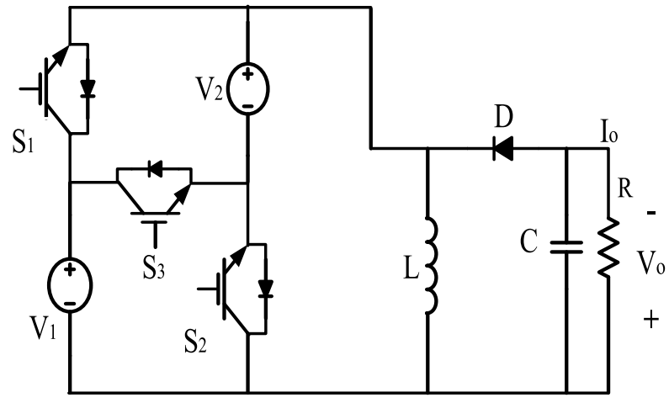

Fig.11: Circuit representation of BDC Converter.

The individual and simultaneous operation of the input energy sources of the converter is accomplished by controlling the power switches S1, S2, and S3. The possible operating modes of the IBDC converter (boost, buck-boost, and buck are decided by the conduction of the power switch Sm and the two diodes available in the converter.

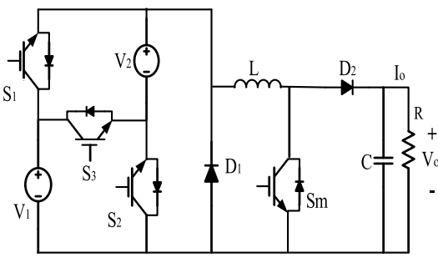

Fig.12: The basic circuit of the IBDC Converter.

|  |  |  |  |  |
| --- | --- | --- | --- | --- |
| Operati-ng State | Sources supplyi-ng | Operating switch | Inductor voltage | Inductor status |
| State-1 | V1 | S1, Sm | V1 | Charging |
| State-2 | V2 | S2, Sm | V2 | Charging |
| State-3 | V1+V2 | S3, Sm | V1 +V2 | charging |
| State-4 | None | D1, D2 | -Vo | Discharging |

Table no. 1: Possible operating states of IBDC converter in buck-boost operation.

The IBDC converter has four operating states in buck-boost operation and the details are briefly mentioned in Table no.1. the operating states of the IBDC converter in buck-boost operation are the same as the operating states of the BDC converter as mentioned earlier. For the simple representation of the circuits in different operating states, the power switches in Fig.11 have been represented as SPST switches in all three modes of operation.

*Buck and Boost Operation of IBDC Converter:* The proposed IBDC converter is capable of buck and boost operation also. These operations can be achieved by proper control of different semiconductor switches available in the IBDC converter. The converter operating states under buck operation.

*State 1:* During state 1, switch S1 and diode D2 are in conduction, while all other switches are non-conducting. So, the inductor is charged by source V1.

*State 2:* Here only the switch S2 and diode D2 are in conduction. So, source V2 charges the inductor.

*State 3:* In this state, the inductor is charged by both the input sources (V1 + V2), which are connected in series. The power switch S3 is in conduction to make the input sources in series.

*State 4:* This state is similar to that of the freewheeling state of the buck-boost operation of the converter. Here, the stored energy in the inductor is delivered to the load through diodes D1 and D2.

*Boost Operation:* The operating states (state 1 and state 2) of the converter in boost operation. In this state, S1 and Sm are operated the inductor will charge V1 volts, S2 and Smoperates then the inductor will charge V2 Volts and only S2 are operated and the remaining are not operated then the IBDC will act as a Boost converter with the V2 voltage. If S1 operates and the remaining are not operated then the IBDC will act as the Boost converter with the Voltage source V1 [15].

*Multiple Input Multiple Output DC to DC Converter:* Most of the electrical systems are supplied by one type of energy source e.g. utility line power, solar, wind, etc. In some cases, systems are powered by two sources like UPS. In most cases, one source is preferred over all other sources or a simultaneous combination of different sources is appropriate for optimum economical use. Thus, a multiple-input power converter is required. Using multiple inputs, the energy source is diversified to increase reliability and utilization of renewable sources. As most renewable energy sources have outputs in the form of Dc voltage and every source has its voltage and current characteristics e.g. Photovoltaic cells, fuel cells, etc. Therefore, a multiple-input DC-DC converter is of practical use. The problem of multiple inputs interfacing for reliable supply can be solved by MISO circuits. There is another problem of load diversity, different loads operate on different voltages thus multiple outputs are also required. This concludes the requirement of a MIMO DC-DC Converter. Recently, microgrids with a combination of different energy storage units and renewable energy sources have changed the research interest due to environmental considerations and reliability requirements. In such circumstances, Multi-Port Converters (MPC) play a vital role in interfacing and integrating these energy sources to supply the loads. MPCs can be classified technically into isolated and non-isolated topologies. Hybrid converters are another group of converters and refer to those which have input ports for AC as well as for DC or a combination of both. In the previous few years, a lot of research is done on MPCs. Most of the researchers propose the MISO converter to combine the different energy sources at different voltage levels. The problem with these converters is that only one source can supply power to the load at a time. Some of these researches show that their topologies contain certain features like the MISO can budget the power between different energy sources. An attempt to solve the problem of load diversity is taken into consideration by designing a MIMO converter. The MIMO ensures a smooth switching of power between loads dividing the current of sources which ultimately distributes the power accordingly. The topology of the MIMO converter by designing a Matrix Buck-Boost Converter (MBBC) [17]. The circuit diagram of the MIMO converter is shown in Fig.13.

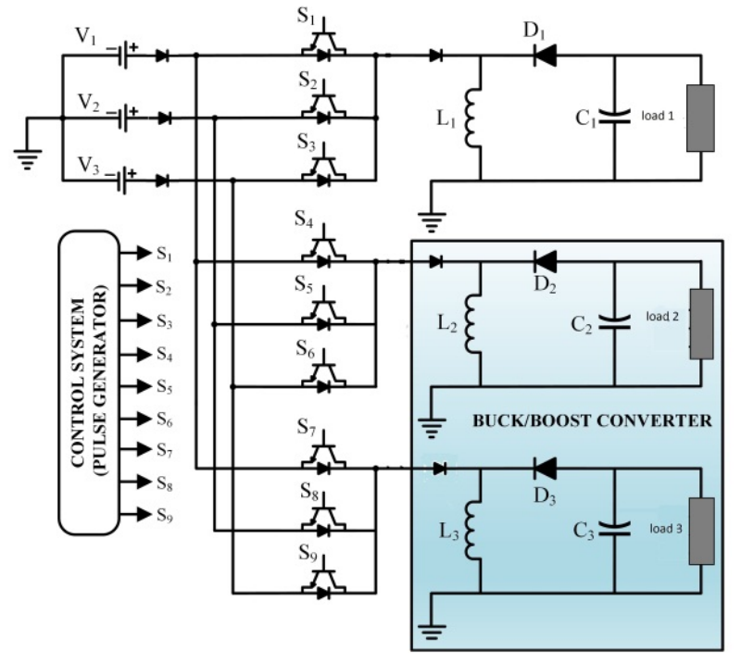

Fig.13: Circuit diagram of MIMO converter.

***3. Inverters:*** The device which can convert electrical energy from dc form into ac form is known as a power inverter. They can come in different sizes and shapes and can vary from a high-power rating to a very low power rating, also they are different in efficiency, price, and purpose. DC to AC inverters are being widely used in ordinary household and industrial purposes to have an uninterruptable power supply. But nowadays inverters have become a very important part of renewable energy applications as they are used to link a wind system or photovoltaic system or another form of renewable energy to a power grid.

*PWM Inverter:* A dc to ac inverter normally operates based on the pulse width modulation (PWM) technique. The semiconductor switches of the inverter are turned on and turned off by this modulation technique. The semiconductor switched to control the duration and direction of current through a load which ultimately converts the dc signal into a signal. When a dc signal is converted into a sinusoidal ac signal with the help of an inverter, the sinusoidal signal contains many types of harmonics. A pure sinusoidal wave is a notional quantity as harmonic are always present in periodic waves. The level of harmonic distortion present is measured by a common term known as total harmonic distortion (THD). Pulse width modulation (PWM) is characterized by the generation of uniform amplitude pulses by modulating the duration and duty cycle of pulses. The inverter switches are turned on and turned off by controlling the duration and duty cycle of the gate pulse. In this technique, by adjusting the on and off periods of the inverter switches, a dc input voltage is converted into an ac output voltage. Different PWM techniques are used to control the on and off periods of the switches of the inverter. The PWM signals are pulses with constant frequency, magnitude, and variable pulse width. The reference signal may be a sinusoidal or square wave and the carrier signal is a saw tooth or triangular wave. In the PWM technique, the frequency of the carrier signal is greater than the frequency of the reference signal. The PWM technique can be categorized into various types according to different patterns of reference signals [12] [18-23]. The basic circuit diagram for the PWM inverter is shown in Fig.14.

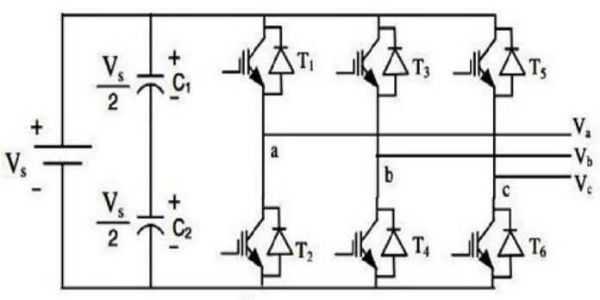

Fig.14: Circuit Diagram for PWM Inverter.

Classification of PWM Technique.

* Sine Pulse Width Modulation (SPWM) [12,18]
* Space Vector Pulse Width Modulation (SVPWM) [19-23]
* Third Harmonic Injected Pulse Width Modulation (THPWM) [18]
* Trapezoidal Pulse Width Modulation (TRPWM) [18]
* Sixty Degree Pulse Width Modulation (SDPWM) [18]
* Discontinuous Pulse Width Modulation (DPWM) [19-23]
  + Discontinuous Pulse Width Modulation MIN (DPWMMIN)
  + Discontinuous Pulse Width Modulation MAX (DPWMMAX)
  + Discontinuous Pulse Width Modulation 0 (DPWM0)
  + Discontinuous Pulse Width Modulation 1 (DPWM1)

*Three-Phase Four-Leg VSI:* The structure of a three-phase four-leg voltage-source inverter is shown in Fig.14, which is similar to the two-level VSI, but with an additional leg connected to the neutral point of the load through an inductor (Ln). Moreover, it can be noticed that the capacitors of the output filter are also connected to the neutral point. The additional leg provides the possibility of managing the neutral point currently, therefore, it is possible to handle unbalanced and nonlinear loads keeping low ripples on the DC link capacitors’ voltage. The implementation of an additional leg implies a significant increment in the hardware required and more complicated control strategies. In this Three Phase, with Four-leg Voltage-source Inverter a neutral problem is rectified.

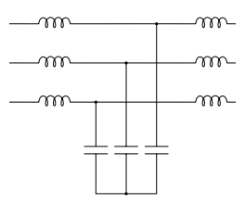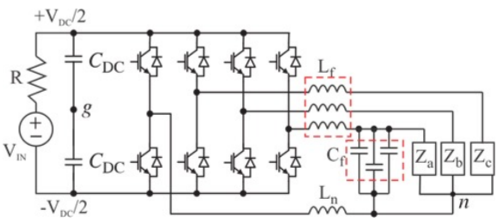

Fig.15: Circuit Topology for Three-Phase Four-Leg VSI

***4. Filters:*** The use of a three-phase inverter has become very popular in recent decades for a wide range of applications. The control of a three-phase inverter is one of the most important and classical subjects in power electronics and has been extensively studied in the last decades. The control of inverters output has special importance in applications where a high-quality voltage is needed. The Filters are used to reduce the THD and obtain the quality output. The filters are classified into AC filters and DC filters. There are a few arrangements for the filter circuit.

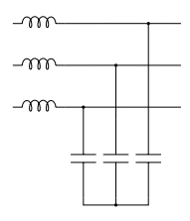 *LC Filter:* The design of the filter is set by specifying the cut-off frequency of the filter, damping criteria, and the resonant frequency of the motor winding with the filter capacitance. The filter effectively reduces high-frequency harmonics which can cause motor bearings and insulation damage, Grid Failure, load damage, reducing the life span of the equipment, etc. For non-linear loads, the inverter output impedance must be minimized, which minimizes distortion. Therefore, by specifying the cut-off frequency the capacitance should be maximized and the inductance minimized. Fig.16 shows the arrangement of the LC Filter in Three-phase. This decreases the overall cost, weight, and volume of the L-C filter. The design of an L-C filter can start with selecting passive L-C elements as prototypes. [24] Fig.16: LC Filter

*LCL Filter*: Traditionally, an LC filter is used for an inverter power supply. A grid-interconnected inverter used in distributed generation (DG), however, has some unique requirements that an LC filter may not be sufficient. A PWM converter with a higher switching frequency will result in a smaller LC filter size. However, switching frequency is generally limited in high-power applications. As an alternative solution, the LCL filter is more attractive for two reasons: First, it has better attenuation than the LC filter given the similar size. Fig.17 shows the arrangement of the LC Filter in Three-phase. Second, the LCL filter provides an inductive output at the grid interconnection point to prevent inrush current compared to the LC filter. Similar to the LC filter, one consideration of the filter design is damping. Active damping is generally more attractive than passive damping. However, the control bandwidth is quite limited in high-power converters due to their low switching frequency. In most cases, passive damping is considered. The filter has three unknown parameters L1, C, and L2. In the following, three considerations that lead to three equations for determining the three unknowns will be discussed [25].

Fig.17: LCL Filter.

***5. Bi-directional Converter for application of battery and EVs Integration:***Bidirectional three-phase DC-AC converters play a key role in applications such as UPS, electric vehicles, grid integration of renewable energy sources, energy storage systems, and microgrids. Regarding the power flow from DC to AC, topologies of three-phase converters can be classified into three categories: Buck-type (Voltage-fed), Boost-Type (Current-fed), and Buck-Boost type topologies. Among them, the Buck-type converters have been the most popular solution for industrial applications due to their simple topology, high efficiency, flexible modulation, and control strategy. However, according to the voltage relationship between the input and output voltage of the Buck-type converters, the DC input voltage must be greater than the peak amplitude of the AC line voltage. In practical applications, e.g., battery charging/discharging for electric vehicles and energy storage systems, the DC voltage of the storage battery can be either lower or greater than the peak amplitude of AC line voltage. To adapt to the wide DC voltage range, another bidirectional DC-DC converter is required to be cascaded with the DC-AC converter. However, for this two-stage architecture with a cascaded DC-DC converter, all the power has to be processed twice, which significantly degrades the overall efficiency. Many efforts have been made to improve the efficiency of two-stage bidirectional DC-AC power conversion systems. Multilevel DC-AC topologies are effective to reduce the voltage stresses and switching losses of active switches, but the conversion stages cannot be reduced yet.

*Bi-directional Three-Phase DC-AC Converter with Embedded DC-DC Converter:* The bidirectional three-phase DC-AC converter with embedded DC-DC converter is shown in Fig.18, where a DP-TPC is employed and responsible for bidirectional DC-AC conversion. It is seen that dual DC ports, i.e., low-voltage DC port and high-voltage DC port, are provided simultaneously by the DP-TPC. The LV DC port is directly connected to the battery, while the HV one is connected to the intermediate bus. A new power flow branch between the battery and the AC grid is built by the DP-TPC, utilizing introducing a bidirectional switch, i.e., two series-connected IGBTs SLx1 and SLx2 (x=a,b,c), to each switching-leg. Hence, part of the power can be directly supplied from the battery to the AC grid without being processed by the embedded DC-DC converter, and vice versa [26].

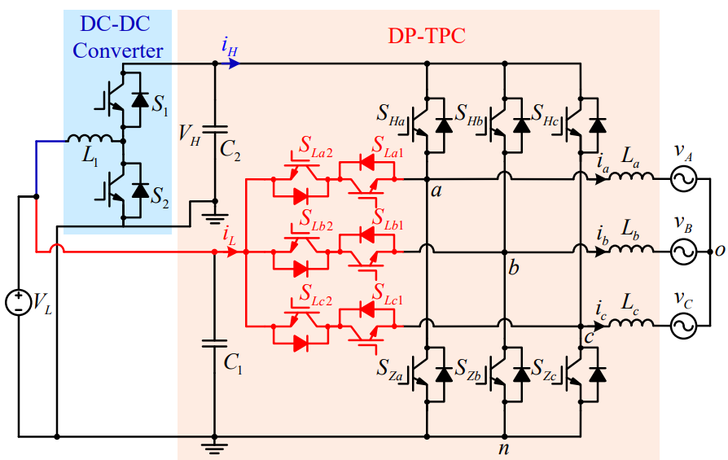

Fig.18: Bi-directional Three-phase DC-AC Converter with embedded DC-DC Converter.

*Bi-directional Three-Phase DC-AC Converter with Bi-Directional DC-DC Converter:* The bi-directional three-phase DC-AC Converter with Bi-directional Buck-Boost converter is shown in Fig. In [27] shows the Bi-directional Buck-Boost Converter Operation. Using the Bi-directional converter the possible flow from the EVs Batteries to the Grid and the Grid to the EVs Batteries by controlling the Bi-directional Buck-Boost Converter. The Bi-directional Buck-boost converter uses the traditional converter. The circuit diagram of a Bi-directional Three-Phase DC-AC Converter with a Bi-Directional DC-DC Converter is shown in Fig.19

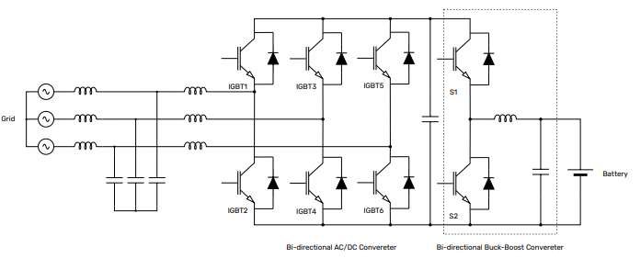

Fig.19: Circuit diagram of Bi-directional DC/AC converter with Bi-directional Buck-boost converter.

*Bi-directional Three-Phase DC-AC Converter with Bi-directional Buck-Boost Cascade Converter:* The bi-directional Three-phase DC-AC converter with the cascade buck-boost converter is shown in Fig. The Bi-directional power flow is performed by controlling of tBuck-Boost Converter. In [27] the operation of the Bi-directional Cascade Buck-Boost Converter is present. This type of converter uses the advanced version of the Bi-directional Buck-Boost converter. Fig.20 Shows the circuit diagram of a Bi-directional Three-phase DC-AC converter with a Bi-directional Buck-Boost cascade converter.

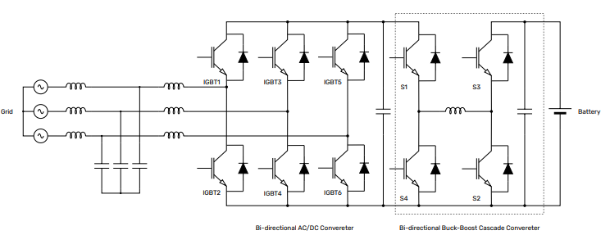

Fig.20: Circuit Diagram of Bi-directional DC/AC converter with Bi-directional Buck-Boost cascade converter.

**IV. CONCLUSION**

In this paper, a study on different types of energy harvesters is presented: Solar Energy, Piezoelectric (Vibration (or) pressure, Sound Waves and Integration in Air Springs), electromagnetic, electrostatic and Electric Vehicles Batteries. It discussed several methods of energy harvesting using various transducers. Mainly, Vibrations were key to driving all of the energy harvesters. Piezoelectric energy harvesters and triangular piezoelectric shapes generate higher energy outputs compared to other shapes. Piezoelectric energy harvesters can be of different sizes depending on the application and it is considered easy to implement.

It was found that a combination of transducers and other electric resources can maximize the energy harvested. The scope of research includes low power consumed devices like monitors and various applications in medical field and cardiac implantations. These advancements represent a promising sector for the increased use of these technologies in the future. The possible sources of energy harvesters are from Foot step, EVs, malls, traffic signals, etc.

In this paper, various converters are presented based on applications, the converter are used. The converters like IBDC, MIMO, Three-Phase PWM Inverters, Three-Phase Four-leg PWM VSI, Bidirectional Three-phase converter with Embedded with DC-DC converter are preferred. In future, the fossil fuel is going to be extend. The possible of the power generation through the traditional method is going to reduce. The future of the possible energy harvesting or power generation is presented in this paper.

##### References

1. Xuan-Dien Do, Chang-Jin Jeong, Huy-Hieu Nguyen, Scok-Kyun Han, and Sang-Gug Lee,” A High-Efficiency Piezoelectric Energy Harvesting System”, 2011 International SoC Design Conference, Jeju, Korea (south), 2011 pp. 389-392.
2. Bavleen Kaur, Abhishek Agnihotri, Deepti Thapar, and Nikhil Arora,” Piezoelectric Energy harvester Design and Power Conditioning with Solar Integration”, 2019 3rd International Conference on Electronics, Materials Engineering & Nano-Technology, Kolkata, India 2019, pp.1-6.
3. Ratnesh Srivastava, Navneet Tiwari, Abhishek Kumar, and Debojyoti Sen, “Power Generation Using Piezoelectric Material”, International Advanced Research Journal in Science, Engineering, and Technology (IARJSET), National Conference on Renewable Energy and Environment (NCREE-2015).
4. A. Durgadevi, S. Arulselvi and S. P. Natarajan,” Photovoltaic Modeling and its Characteristics”, 2011 International Conference on Emerging Trends in Electrical and Computer Technology, Nagercoil, India 2011, pp.469-475.
5. Alireza Khaligh, Peng Zeng and Cong Zheng, “Kinetic Energy Harvesting Using Piezoelectric and Electromagnetic Technologies-State of the Art” in IEEE Transactions on Industrial Electronics, Vol. 57, No.3, pp.850-860, March 2010.
6. N. S. Shenck, “A Demonstration of Useful Electric Energy Generation from Piezoceramics in a Shoe”, MIT, Cambridge, 1999.
7. P. Pomdrom, J. Hillenbrand, G. M. Sessler, J. Bos, and T. Melz, “Vibration-based energy harvesting with stacked piezoelectric” Applied Physics Letters, Vol. 104, Issue 17,2014.
8. Liew Hui Fang, Syed Idris Syed Hassan, Rosemizi Abd Rahim, Muzamir Isa, and Baharuddin bin Ismail, “Exploring Piezoelectric for Sound Wave as Energy Harvester”, The 8th International Conference on Applied Energy- ICAE2016, Vol. 105, pp.459-466.
9. Andrea Genovese, Salvatore Strano, and Mario Terzo, “Study of a Vibration-based Piezoelectric energy harvester embedded in an air Spring” 2019 IEEE 5th International Forum on Research and Technology for Society and Industry (RTSI), Florence, Italy,2019. pp.314-31.
10. Abdul-Rahman El-Sayed, Kevin Tai, Mohammad Biglarbegian and Shohel Mahmud, ”A Survey on Recent Energy Harvesting Mechanisms”, 2016 IEEE Canadian Conference on Electrical and Computer Engineering (CCECE), 2016, pp.1-5.
11. Ravindra B. Kuhada, Anandsingh P. Chauhan and Naran M. Pindoriya,” Real-time Simulation of V2G Operation for EV battery”, 2020 21st National Powers Systems Conference (NPSC), Gandhinagar, India.
12. William Shepherd and Li Zhang, “Power Converter Circuits” Copyright ©2014 by Marcel Dekker, Inc
13. Sachin Kale and Dr. N. R. Bhasme, “DC to DC Converters and Its Application for Railway System- A Review”, International Journal of Electrical Engineering & Technology (IJEET), Vol 10, Issue 4, Jul-Aug 2019, pp. 13-21.
14. Reshma M S, Midhun Basil Alias, Haritha S Nair and Priya Jose, “Cuk Converter Fed Electric Vehicles”, National Conference on Emerging Research Trends in Electrical, Electronics & Instrumentation
15. Siva Prasad Athikkal, Gangavarapu Guru Kumar, Kumaravel Sundar Moorthy, and Ashok Sankar, ”Performance Analysis of Novel Bridge Type Dual Input DC-DC Converters”, 2017 IEEE translations and content mining are permitted for academic research only.
16. I. Yamamoto, K. Matsui and M. Matsuo, “A Comparison of Various DC-DC Converters and Their Application to Power Factor Correction”, Proceedings of the Power Conversion Conference-Osaka 2002, Vol.1, pp.128-135
17. Faraz Ahmad, Aziz Ahmad Haider, Hassan Naveed, Atay Mustafa, and Irshad Ahmad, “Multiple Input Multiple Output DC to DC Converter”, 2018 5th International Multi-Topic ICT Conference (IMTIC), Jamshoro, Pakistan, 2018, pp. 1-6.
18. Airin Rahman, Md. Moshiur Rahman and Md. Rabiul Islam, “Performance Analysis of Three Phase Inverters with Different Types of PWM Techniques”, 2nd International Conference on Electrical & Electronics (ICEEE), 27-29 Dec 2017, Bangladesh, pp. 1-4.
19. P. Rama Mohan, T. Bramhananda Reddy, and M. Vijaya Kumar, “Simple and Efficient High-Performance PWM Algorithm for Induction Motor Drives”, Journal of Electrical Engineering, Vol 11, Issue 4.
20. Wang Xu, Huang Kaizheg, Yan Shijie, and Xu Bin, “Simulation of Three-Phase Voltage Source PWM Rectifier Based on the Space Vector modulation”, 2008 Chinese Control and Decision Conference, pp.1881-1884.
21. Ahmet M. Hava, Russel J. Kerkman, and Thomas A. Lipo, “A High-Performance Generalized Discontinuous PWM Algorithm”, IEEE Transactions on Industry Applications, Vol.34, No.5, pp.1059-1071. Sep/Oct 1998.
22. Dae-Woong Chung, Joohn-Sheok Kim, and Seung-Ki Sul, “Unified Voltage Modulation Technique for Real-Time Three-Phase Power Conversion”, IEEE Transactions on Industry Applications, Vol. 34, No. 2, pp.374-380. Mar/Apr 1998.
23. Ahmet M. Hava, Russel J. Kerkman, and Thomas A. Lipo,” Simple Analytical and Graphical Methods for Carrier-Based PWM-VSI Drives”, IEEE Transactions on Power Electronics, Vol.14, NO.1, pp.49-61, Jan 1999.
24. Manoj D. Patil and Rohit G. Ramteke,” L-C Filter Design Implementation and Comparative Study with Various PWM Techniques for DCMLI”, 2015 International Conference on Energy System and Applications, pp.347-352, 30 Oct – 01 Nov.
25. Timothy CY Wang, Zhihong Ye, Gautam Sinha, and Xiaoming Yuan, “Output Filter Design for a Grid-interconnected Three-Phase Inverter “, IEEE 34th Annual Conference on Power Electronics Specialist,2003. PESC’03, Mexico, pp. 779-784 Vol.2.
26. J. Wang, H. Wu, T. Yang, L. Zhang, and Y. Xing, “Bidirectional Three-Phase DC-AC Converter with Embedded DC-DC Converter and Carrier-Based PWM Strategy for Wide Voltage Range Applications”, IEEE Transactions on Industrial Electronics, Vol.66, no.6, pp.4144-4155, June 2019.
27. F. Caricchi, F. Crescimbini, F. Giulli Capponi and L. Solero, “Study of Bi-Directional Buck-Boost Converter Topologies for Application”,